okv endpoint migration POA

Step 1: Disable the encryption in mysql

Step 2 : Install below packages on Mysql server.
yum install java-1.8.0-openjdk.x86_64
yum install java-devel

Step 3: In my.cnf comment bellow mentioned lines
#early-plugin-load=keyring_okv.so
#keyring_okv_conf_dir=/var/lib/oracle/okvutil

Step 4: Mysql restart

Step 5: Suspend endpoint from old okv GUI Console

Step 6: Now Point, new endpoint from new okv console, follow POA present in WIKI

Take Login on Oracle Key Vault server using SYSADMIN user.
To create endpoint click on endpoint tab & then on Add button.

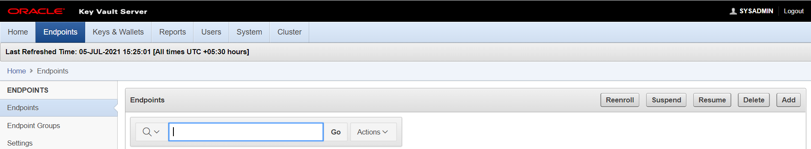
Fill up information for new endpoint & Click on Register button.
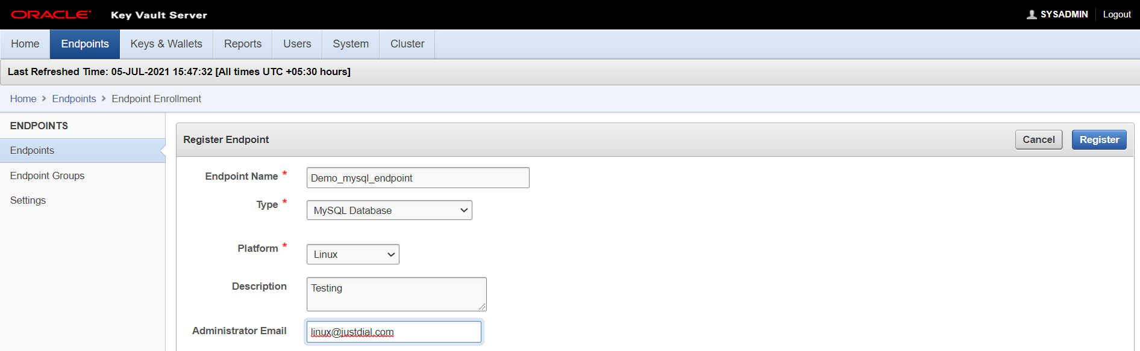
Copy Enrollment Token to notepad & click on logout button.
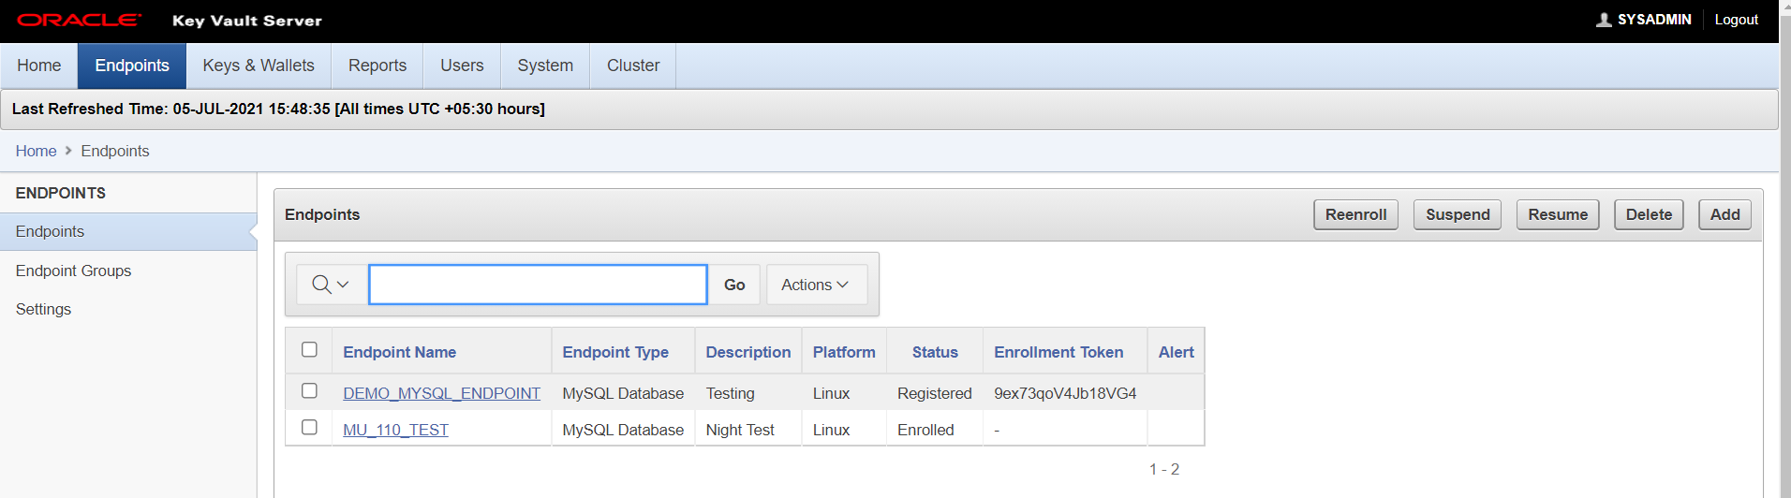
Now click on “Endpoint Enrollment and Software Download”
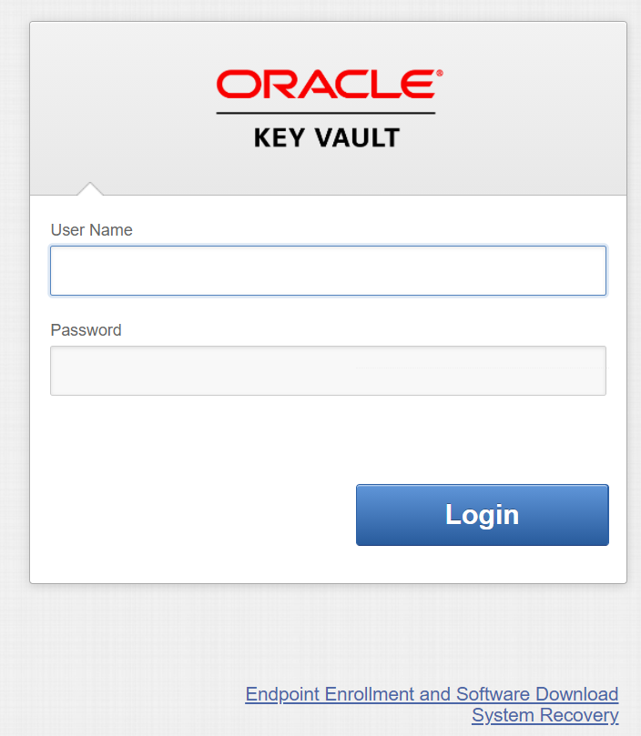
Fillup information of endpoint and click on submit token button. It will check & provide you confirmation “Valid Token”.
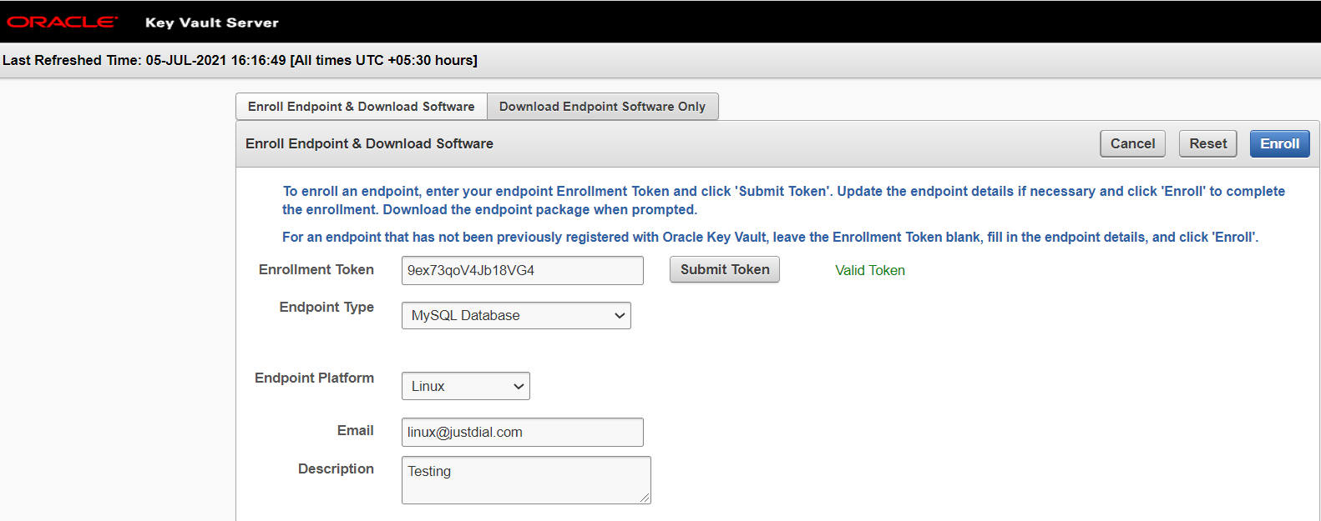
Now click on Enroll button.
After you click on Enroll button you will find one jar file get download on your local machine “okvclient.jar”
Copy this file to client machine.

Note : copy okvclient.jar to /tmp for use in step 5

7) Create directory as per below
mkdir -p /var/lib/oracle/okvutil
mkdir -p /usr/local/mysql/mysql-keyring-okv

8. Change permission of oracle directory.
chown mysql. /var/lib/oracle -R

9) Run below command (run below command from the directory from where )
java -jar okvclient.jar -d /usr/local/mysql/mysql-keyring-okv -v

10) Run below command
/usr/local/mysql/mysql-keyring-okv/bin/okvutil list -v 4

11) Got to /tmp & extract ssl directory
jar xf okvclient.jar ssl

12) Copy ssl directoy to provided path
cp -rp ssl /var/lib/oracle/okvutil/

13) Copy below directories
cp /usr/local/mysql/mysql-keyring-okv/conf/okvclient.ora /var/lib/oracle/okvutil/

cp /usr/local/mysql/mysql-keyring-okv/ssl/* /var/lib/oracle/okvutil/ssl/

14) Change permission of directory
chmod 664 /var/lib/oracle/okvutil/okvclient.ora
chmod 775 /var/lib/oracle/okvutil/ssl
chmod 664 /var/lib/oracle/okvutil/ssl/*
chmod 750 /var/lib/oracle/okvutil/ssl/ewallet.p12
chmod 750 /var/lib/oracle/okvutil/ssl/cwallet.sso

15) Your directory structure should be look like this.
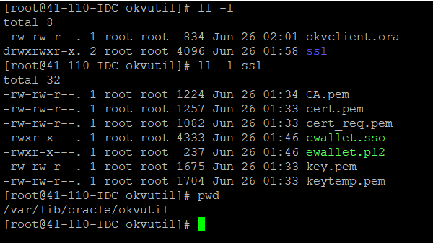

16) In my.cnf uncomment bellow mentioned lines
#early-plugin-load=keyring_okv.so
#keyring_okv_conf_dir=/var/lib/oracle/okvutil

17) Now restart mysql service.

18) Before you attempt to create an encrypted table, you can check and make sure the plugin is active via this command
mysql> SELECT PLUGIN_NAME, PLUGIN_STATUS FROM INFORMATION_SCHEMA.PLUGINS WHERE plugin_name=’keyring_okv’;

Steps to verify.
19) To create a database and table with encryption, you only need to add ENCRYPTION = ‘Y’ to the CREATE TABLE statement.

#mysql> create database test_okv;
#mysql> use test_okv;
#mysql> CREATE TABLE pet (name VARCHAR(20), owner VARCHAR(20));
#mysql> ALTER TABLE pet ENCRYPTION='Y';
ERROR 1178 (42000): The storage engine for the table doesn't support ENCRYPTION
#mysql> ALTER TABLE pet ENGINE = InnoDB;
Query OK, 0 rows affected (0.05 sec)
#mysql> ALTER TABLE pet ENCRYPTION='Y';
#mysql> ALTER TABLE pet ENCRYPTION='N';
#mysql> drop database test_okv;

Below command is to get encrypted tables from database server :
#SELECT table_schema,table_name,create_options FROM information_schema.tables WHERE create_options LIKE ‘%encryption%’;

